Annie Mae

# Download and Install Preprose and Bootstrap 4

Download and install Preprose.

**$cd** to the project folder root.

**$npm init** to create a package.json file.

**$npm install bootstrap - -save** to save as a dependencie which will be listed in the package.json file.

In the package.json file enter:

"jquery": "1.9.1 - 3",

"popper.js": "^1.12.9"

Or from the cmd, for the latest version, enter:

npm install jquery –save

npm install popper.js –save

# Setup Folder Structure

In the project root add a folder named src, inside that add a folder named sass and a folder named js. In the sass folder add a folder named vendor.

Copy the bootstrap.scss file into src > sass > vendor folder, add the new path and select the components needed, deselect the one’s that are not needed.

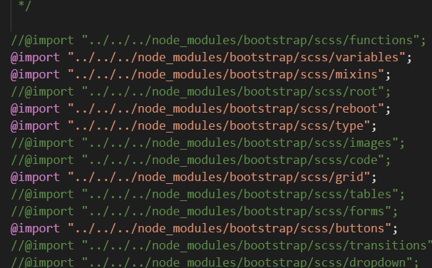

In the src > sass folder add a folder named main.scss and @import vendor/bootstrap.

**Setup Git**

In project root add a .gitignore file.

**$cd** into project root**.**

**$git init.**

Inside Github create new repository.

Copy **git remote add origin** [**https://github.com/james20381/annie-marie.git**](https://github.com/james20381/annie-marie.git)into cmd.

**$git add .**

**$git commit –m “Initial Commit – Laravel Install”**

**$git push –u origin master.**

**Push the New Edits to Github**

**$git add .**

**$git commit –m “”**

**$git push.**